Fruit anatomy
Before going into types of fruits, it may be important to understand some basic fruit anatomy. Pericarp is a term used to describe the tissues of a fruit surrounding the seed(s). It mainly refers to the wall of a ripened ovary, but it has also been used in reference to fruit tissues that are derived from other parts of the flower. Pericarps consist of three layers (although not all fruits have all layers): endocarp, mesocarp, and exocarp (also known as epicarp). The pericarps of true fruits consist of only ovarian tissue, while the pericarps of accessory fruits consist of other flower parts such as sepals, petals, receptacles.
Fruits can be either fleshy or dry. Tomatoes are fleshy fruits, and dandelion fluffs are dry fruits. Dry fruits can be further broken down into dehiscent fruits and indehiscent fruits. Dehiscent fruits – like milkweeds and poppies – break open as they reach maturity, releasing the seeds. Indehiscent fruits – like sunflowers and maples – remain closed at maturity, and seeds remain contained until the outer tissues rot or are removed by some other agent.
Most fruits are simple fruits, fruits formed from a single ovary or fused ovaries. Compound fruits are formed in one of two ways. Separate carpels in a single flower can fuse to form a fruit, which is called an aggregate fruit; or all fruits in an inflorescence can fuse to form a single fruit, which is called a multiple fruit. A raspberry is an example of an aggregate fruit, and a pineapple is an example of a multiple fruit.

The pericarp is divided into three distinct sections:
The first is the endocarp, or inner layer or better known to most people as the hard pit of the fruit. Inside the endocarp is the seed of the fruit.
The second section is the mesocarp, or middle layer and is what most people would consider the flesh of the fruit and is the majority of the mass.
The exocarp, or the outer layer makes up the skin of the fruit.
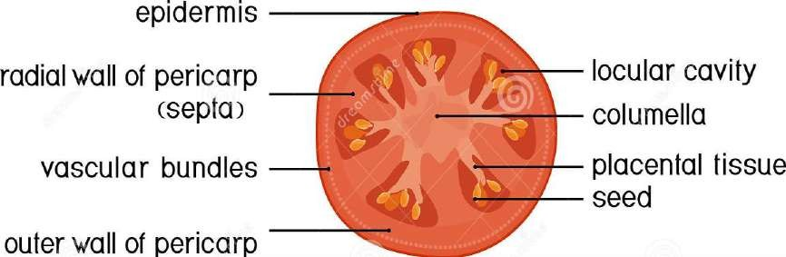
Part of fruits

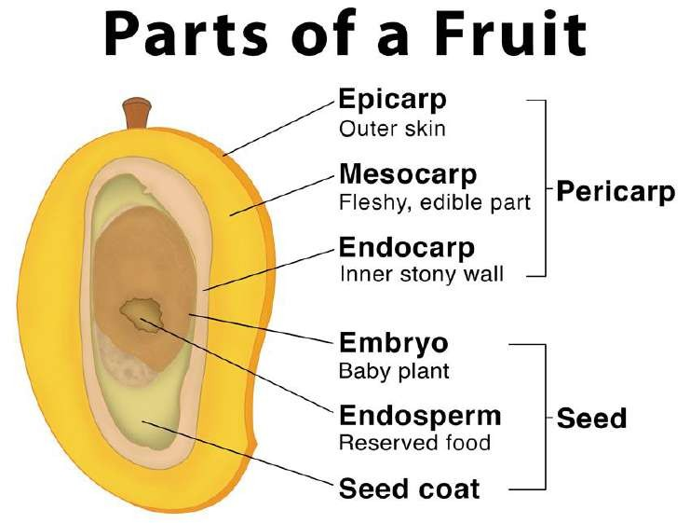

External Seed Anatomy
  - Seed coat: The protective, outer layer of the seed. Seed coats develop from the integuments of the ovule.
  - Micropyle: A tiny hole through the seed coat.
    - Initially, this is the hole through the integuments utilized by the sperm to fertilize the egg.
    - Later, this hole allows water to enter the seed during imbibition.
  - Hilum – The scar from the funiculus.
    - The funiculus is essentially the (umbilical cord) that attached the parent plant to the developing seed. The parent plant must transfer enough resources into the developing seed that the embryonic plant can grow its first true leaves and begin feeding itself through photosynthesis.
    - Thus, the hilum is equivalent to a person’s belly button.

Internal Seed Anatomy
Cotyledon – The embryonic leaf of seed-bearing plants consisting largely of energy-storing proteins that nourish the embryo as it grows. The cotyledons are the first structures out of a germinating seed. Monocots have only a single cotyledon in the seed. Dicots have two cotyledons in their seeds. Cotyledons are essentially the “baby food” for the growing embryo, but they are not the only energy-storing tissue found in seeds.

Angiosperms (the flowering plants) have both endosperm and cotyledons while gymnosperms (the non-flowering plants) have only a nutritive nucellus. Monocots and dicots utilize their cotyledons differently.
    - Monocots use their cotyledon energy to grow the embryo inside the seed and then rely on the endosperm to provide the energy to germinate. Thus, the bulk of monocot seeds is the endosperm.
    - Dicots use the endosperm as fuel to grow the embryo. The energy for germinating comes from the two cotyledons that make up the bulk of these seeds.
  - Embryonic plant – The young sporophyte in the seed that consists of the plumule, epicotyl, hypocotyl, and radicle.
    - Plumule – The top of the embryonic plant that represents the shoot or embryonic stem.
    - Epicotyl – The very tip of the plumule. This part of the embryonic stem is above the embryonic attachment to the cotyledons.
      - In monocots, the epicotyl will produce the first true leaves of the plant. Monocot epicotyls are surrounded by a protective sheath referred to as the coleoptile.
    - Hypocotyl – The part of the embryonic stem that is below the attachment point of the cotyledons. The hypocotyl is directly above the embryo’s root.
    - Radicle – The embryonic root.
      - In monocots, the coleorhiza is a protective sheath that surrounds the radicle.
